Date: 15/04/26
📊 Final Count:
🟢 Bullish | 143
🔴 Bearish | 7
Total | 150

🟢 BULLISH TRADES --- 143
1 | ABB26AprFUT
2 | AUBANK26AprFUT
3 | ADANIENT26AprFUT
4 | ADANIGREEN26AprFUT
5 | ADANIPORTS26AprFUT
6 | ABCAPITAL26AprFUT
7 | ALKEM26AprFUT
8 | AMBER26AprFUT
9 | AMBUJACEM26AprFUT
10 | APOLLOHOSP26AprFUT
11 | ASHOKLEY26AprFUT
12 | ASIANPAINT26AprFUT
13 | DMART26AprFUT
14 | AXISBANK26AprFUT
15 | BSE26AprFUT
16 | BAJFINANCE26AprFUT
17 | BANDHANBNK26AprFUT
18 | BDL26AprFUT
19 | BEL26AprFUT
20 | BHARATFORG26AprFUT
21 | HINDZINC26AprFUT
22 | POWERINDIA26AprFUT
23 | ICICIGI26AprFUT
24 | INDIANB26AprFUT
25 | IEX26AprFUT
26 | IREDA26AprFUT
27 | INOXWIND26AprFUT
28 | JINDALSTEL26AprFUT
29 | JSWENERGY26AprFUT
30 | JSWSTEEL26AprFUT
31 | JUBLFOOD26AprFUT
32 | KEI26AprFUT
33 | KALYANKJIL26AprFUT
34 | KAYNES26AprFUT
35 | LTF26AprFUT
36 | LT26AprFUT
37 | LAURUSLABS26AprFUT
38 | LODHA26AprFUT
39 | M&M26AprFUT
40 | MANKIND26AprFUT
41 | TMPV26AprFUT
42 | TATAPOWER26AprFUT
43 | TATATECH26AprFUT
44 | FEDERALBNK26AprFUT
45 | INDHOTEL26AprFUT
46 | PHOENIXLTD26AprFUT
47 | TITAN26AprFUT
48 | TORNTPHARM26AprFUT
49 | TORNTPOWER26AprFUT
50 | TRENT26AprFUT
51 | TIINDIA26AprFUT
52 | VBL26AprFUT
53 | IDEA26AprFUT
54 | YESBANK26AprFUT
55 | ZYDUSLIFE26AprFUT
56 | BHEL26AprFUT
57 | BHARTIARTL26AprFUT
58 | BOSCHLTD26AprFUT
59 | BRITANNIA26AprFUT
60 | CDSL26AprFUT
61 | COLPAL26AprFUT
62 | CAMS26AprFUT
63 | CONCOR26AprFUT
64 | CUMMINSIND26AprFUT
65 | DLF26AprFUT
66 | DALBHARAT26AprFUT
67 | DELHIVERY26AprFUT
68 | DIVISLAB26AprFUT
69 | EXIDEIND26AprFUT
70 | NYKAA26AprFUT
71 | FORTIS26AprFUT
72 | GODREJPROP26AprFUT
73 | HDFCAMC26AprFUT
74 | HDFCLIFE26AprFUT
75 | HINDALCO26AprFUT
76 | PAYTM26AprFUT
77 | OFSS26AprFUT
78 | PGEL26AprFUT
79 | PIIND26AprFUT
80 | PAGEIND26AprFUT
81 | PERSISTENT26AprFUT
82 | PPLPHARMA26AprFUT
83 | POLYCAB26AprFUT
84 | PRESTIGE26AprFUT
85 | RECLTD26AprFUT
86 | SBILIFE26AprFUT
87 | SHREECEM26AprFUT
88 | SRF26AprFUT
89 | SAMMAANCAP26AprFUT
90 | MOTHERSON26AprFUT
91 | SHRIRAMFIN26AprFUT
92 | SIEMENS26AprFUT
93 | SAIL26AprFUT
94 | SUZLON26AprFUT
95 | ASTRAL26AprFUT
96 | MUTHOOTFIN26AprFUT
97 | HCLTECH26AprFUT
98 | CANBK26AprFUT
99 | PNB26AprFUT
100 | ICICIBANK26AprFUT
101 | UNIONBANK26AprFUT
102 | VEDL26AprFUT
103 | BANKBARODA26AprFUT
104 | BANKINDIA26AprFUT
105 | RBLBANK26AprFUT
106 | SBIN26AprFUT
107 | BIOCON26AprFUT
108 | ICICIPRULI26AprFUT
109 | UNOMINDA26AprFUT
110 | HDFCBANK26AprFUT
111 | INDUSINDBK26AprFUT
112 | LICHSGFIN26AprFUT
113 | PNBHOUSING26AprFUT
114 | CIPLA26AprFUT
115 | GRASIM26AprFUT
116 | MANAPPURAM26AprFUT
117 | PFC26AprFUT
118 | SBICARD26AprFUT
119 | TATASTEEL26AprFUT
120 | BAJAJFINSV26AprFUT
121 | BPCL26AprFUT
122 | ETERNAL26AprFUT
123 | NUVAMA26AprFUT
124 | BAJAJ-AUTO26AprFUT
125 | IOC26AprFUT
126 | VOLTAS26AprFUT
127 | APLAPOLLO26AprFUT
128 | CHOLAFIN26AprFUT
129 | GODREJCP26AprFUT
130 | ANGELONE26AprFUT
131 | AUROPHARMA26AprFUT
132 | INFY26AprFUT
133 | NESTLEIND26AprFUT
134 | SOLARINDS26AprFUT
135 | UNITDSPR26AprFUT
136 | 360ONE26AprFUT
137 | ADANIENSOL26AprFUT
138 | RVNL26AprFUT
139 | DABUR26AprFUT
140 | GAIL26AprFUT
141 | JIOFIN26AprFUT
142 | KPITTECH26AprFUT
143 | ONGC26AprFUT
🔴 BEARISH TRADES --- 7
1 | PIDILITIND26AprFUT
2 | RELIANCE26AprFUT
3 | POLICYBZR26AprFUT
4 | SUNPHARMA26AprFUT
5 | DRREDDY26AprFUT
6 | OIL26AprFUT
7 | COALINDIA26AprFUT

Trade Taken
🟢 BULLISH SIGNAL --- BSE26AprFUT

Nifty Bias : ⚠️ CHOPPY — Choppy ⚠️
Crossover : 2026-04-02 14:00 (13 days ago)
Pullback : 2026-04-13 14:45
Low ₹3320.5 ≤ EMA9(Low) ₹3320.77
High ₹3340.7 (breakout level)
Confirm : 2026-04-15 09:15 (+3 candle)
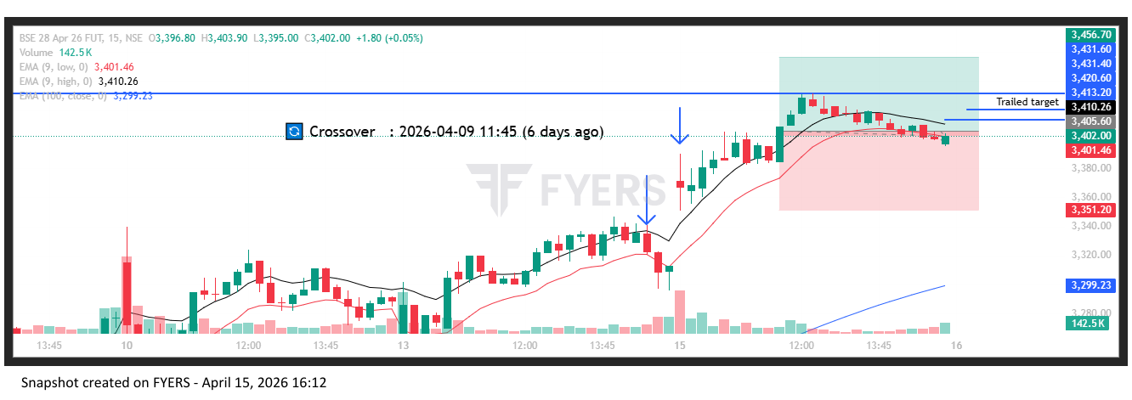
🟢 BULLISH SIGNAL --- BANDHANBNK26AprFUT

Nifty Bias : ⚠️ CHOPPY — Choppy ⚠️
Crossover : 2026-04-06 11:45 (9 days ago)
Pullback : 2026-04-13 15:15
Low ₹166.33 ≤ EMA9(Low) ₹166.38
High ₹167.09 (breakout level)
Confirm : 2026-04-15 09:15 (+1 candle)
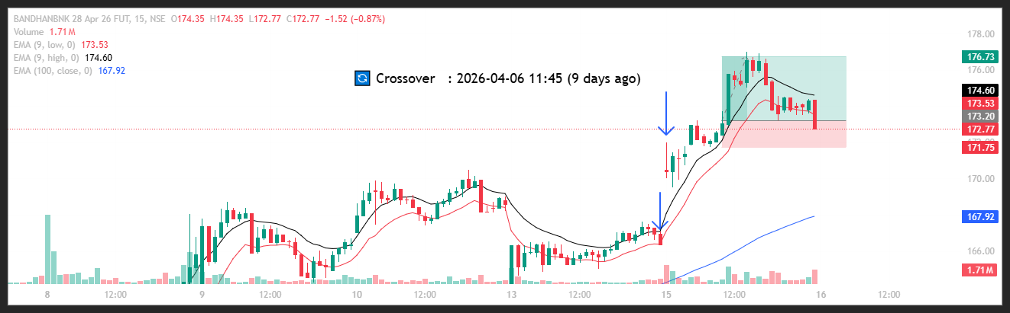
🟢 BULLISH SIGNAL --- LAURUSLABS26AprFUT

Nifty Bias : ⚠️ CHOPPY — Choppy ⚠️
Crossover : 2026-04-02 12:30 (13 days ago)
Pullback : 2026-04-13 15:00
Low ₹1090 ≤ EMA9(Low) ₹1091.16
High ₹1093.15 (breakout level)
Confirm : 2026-04-15 09:15 (+2 candle)
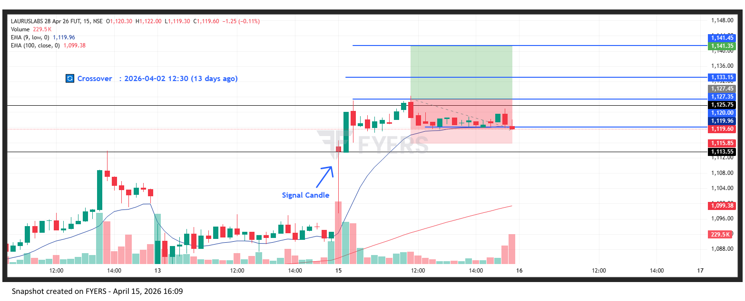
🟢 BULLISH SIGNAL --- LODHA26AprFUT

Nifty Bias : ⚠️ CHOPPY — Choppy ⚠️
Crossover : 2026-04-06 10:15 (9 days ago)
Pullback : 2026-04-13 15:00
Low ₹821 ≤ EMA9(Low) ₹823.41
High ₹824.7 (breakout level)
Confirm : 2026-04-15 09:15 (+2 candle)
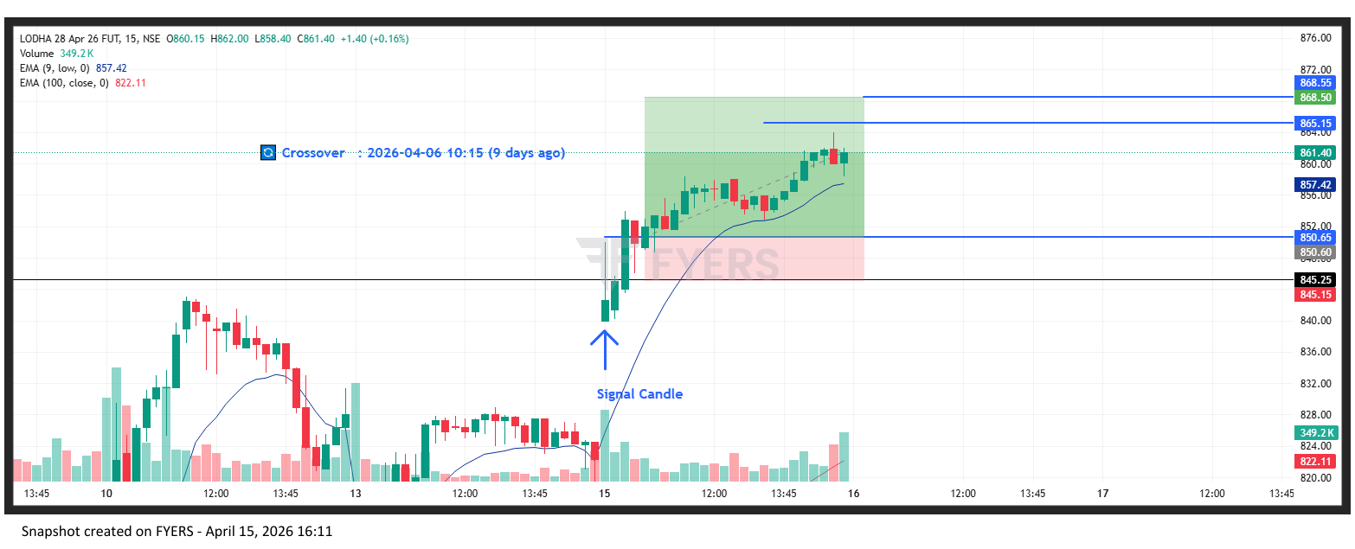
🟢 BULLISH SIGNAL --- TATAPOWER26AprFUT

Nifty Bias : ⚠️ CHOPPY — Choppy ⚠️
Crossover : 2026-04-06 14:00 (9 days ago)
Pullback : 2026-04-13 14:45
Low ₹411.5 ≤ EMA9(Low) ₹412.91
High ₹412.5 (breakout level)
Confirm : 2026-04-15 09:15 (+3 candle)
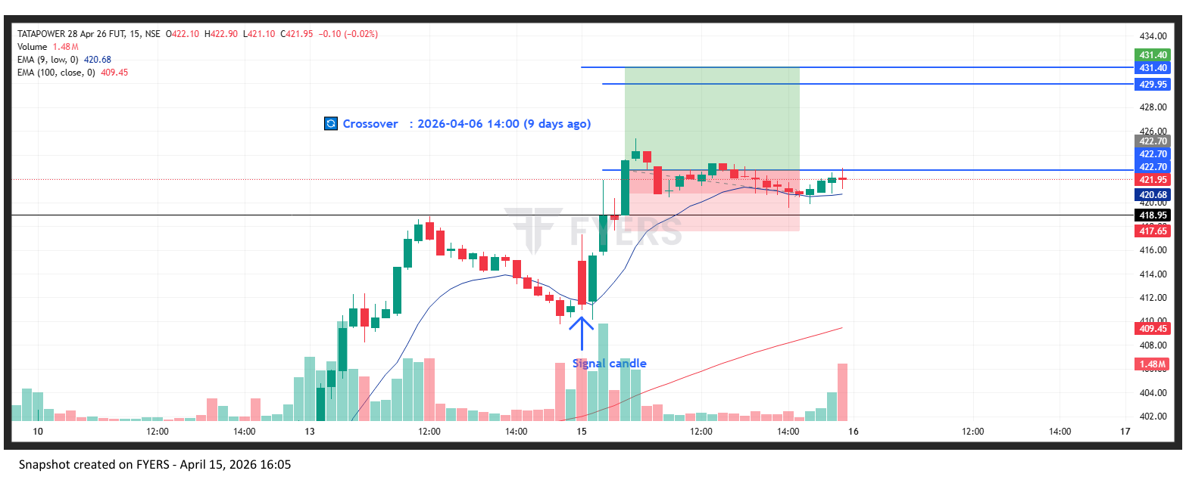
🟢 BULLISH SIGNAL --- VBL26AprFUT

Nifty Bias : ⚠️ CHOPPY — Choppy ⚠️
Crossover : 2026-04-07 12:45 (8 days ago)
Pullback : 2026-04-13 15:00
Low ₹430.55 ≤ EMA9(Low) ₹431.7
High ₹432.65 (breakout level)
Confirm : 2026-04-15 09:15 (+2 candle)
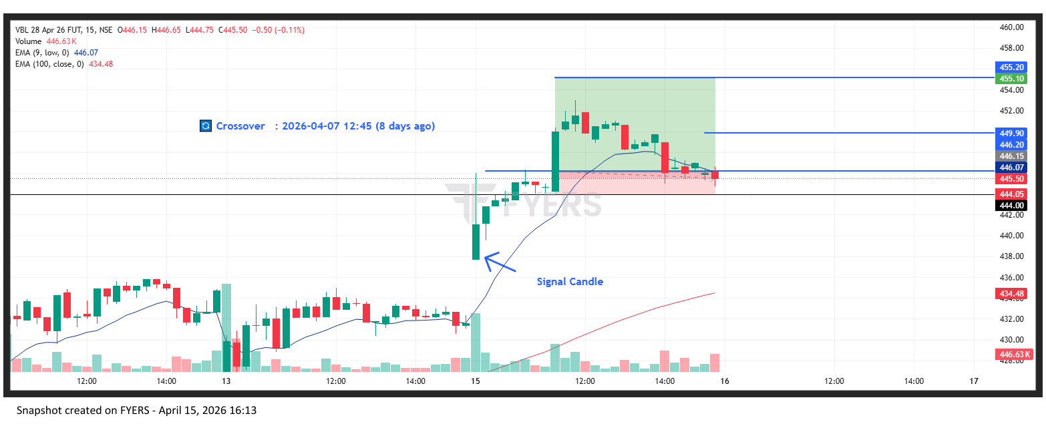
🟢 BULLISH SIGNAL --- ZYDUSLIFE26AprFUT

Nifty Bias : ⚠️ CHOPPY — Choppy ⚠️
Crossover : 2026-04-07 11:30 (8 days ago)
Pullback : 2026-04-13 15:00
Low ₹925.35 ≤ EMA9(Low) ₹926.46
High ₹929.15 (breakout level)
Confirm : 2026-04-15 09:15 (+2 candle)
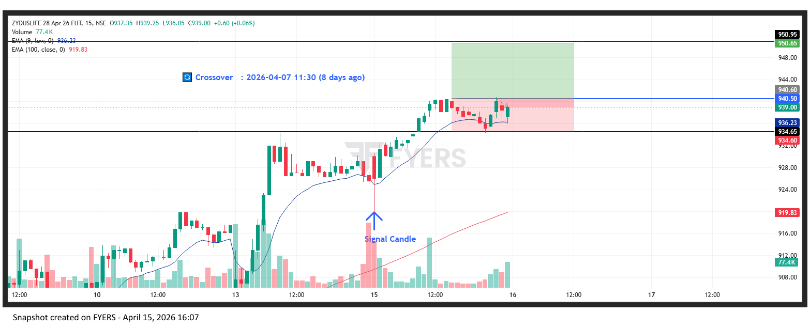
🟢 BULLISH SIGNAL --- PIIND26AprFUT

Nifty Bias : 🟢 LONG — Aligned ✅
Crossover : 2026-04-09 11:45 (6 days ago)
Pullback : 2026-04-13 14:45
Low ₹2920.1 ≤ EMA9(Low) ₹2920.34
High ₹2929.8 (breakout level)
Confirm : 2026-04-15 09:15 (+3 candle)
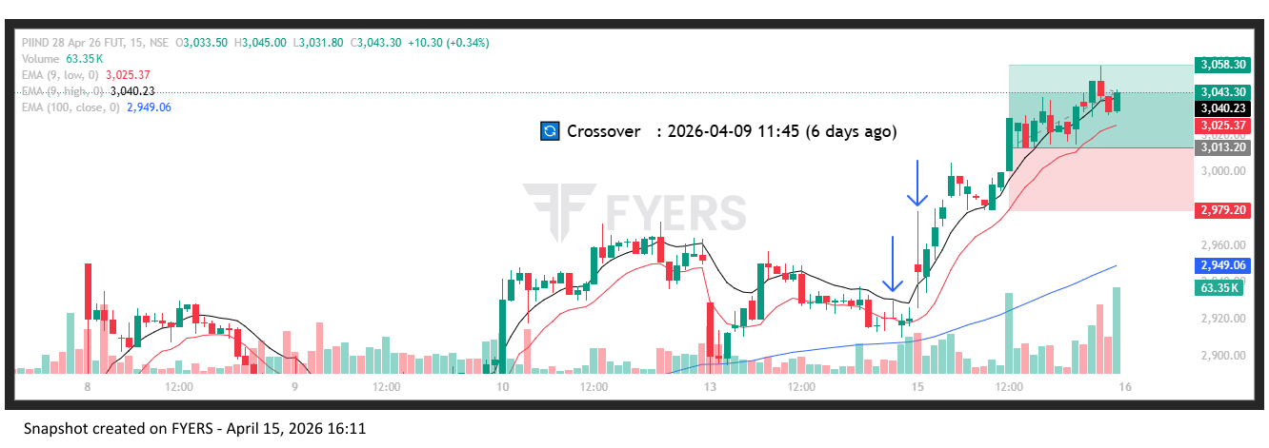
🟢 BULLISH SIGNAL --- POLYCAB26AprFUT

Nifty Bias : 🟢 LONG — Aligned ✅
Crossover : 2026-04-13 11:30 (2 days ago)
Pullback : 2026-04-13 15:00
Low ₹7563 ≤ EMA9(Low) ₹7572.99
High ₹7590 (breakout level)
Confirm : 2026-04-15 09:15 (+2 candle)
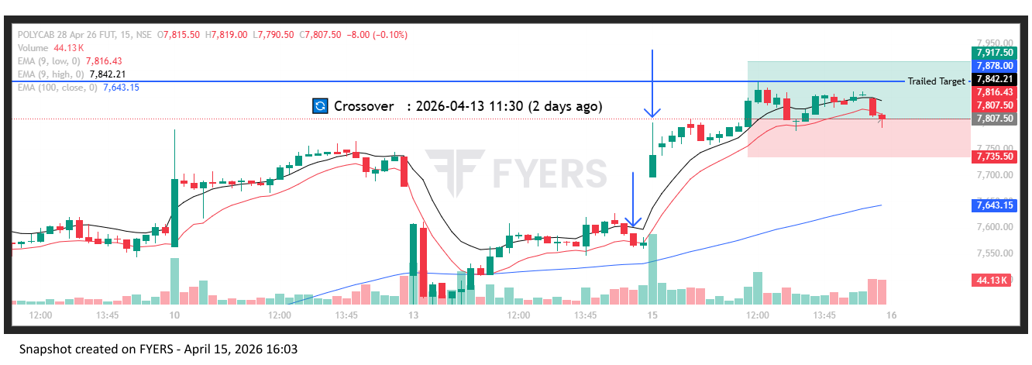
🟢 BULLISH SIGNAL --- SIEMENS26AprFUT

Nifty Bias : 🟢 LONG — Aligned ✅
Crossover : 2026-04-06 13:30 (9 days ago)
Pullback : 2026-04-13 14:45
Low ₹3364 ≤ EMA9(Low) ₹3370.17
High ₹3378.7 (breakout level)
Confirm : 2026-04-15 09:15 (+3 candle)
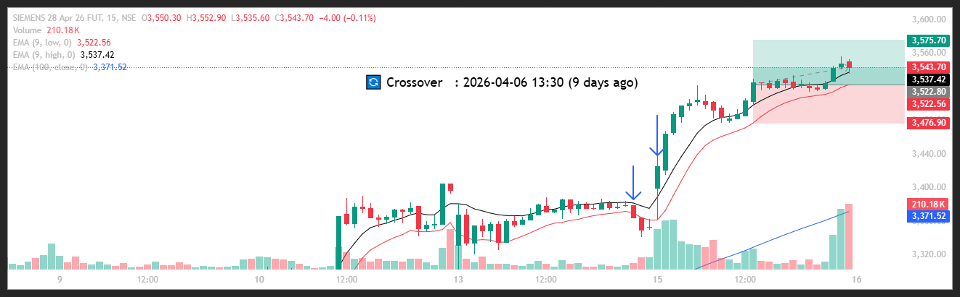
🟢 BULLISH SIGNAL --- SUZLON26AprFUT

Nifty Bias : 🟢 LONG — Aligned ✅
Crossover : 2026-04-06 12:00 (9 days ago)
Pullback : 2026-04-13 15:00
Low ₹45.87 ≤ EMA9(Low) ₹45.88
High ₹46.2 (breakout level)
Confirm : 2026-04-15 09:15 (+2 candle)
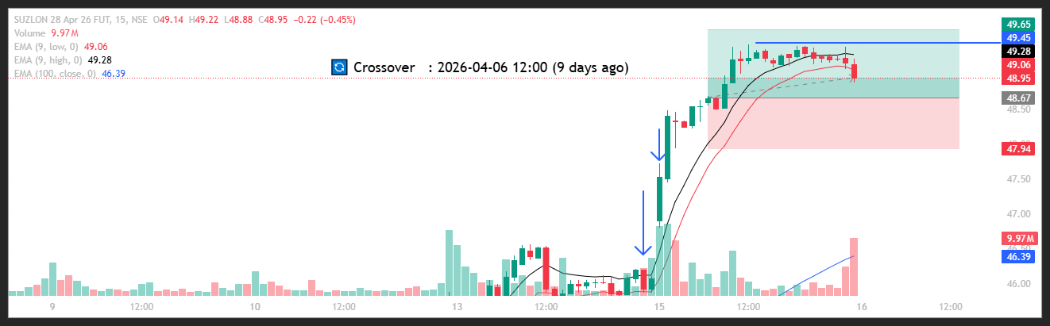

Trade Not Taken
🟢 BULLISH SIGNAL --- ABB26AprFUT

Nifty Bias : ⚠️ CHOPPY — Choppy ⚠️
Crossover : 2026-04-02 14:15 (13 days ago)
Pullback : 2026-04-13 15:00
Low ₹6822.5 ≤ EMA9(Low) ₹6842.77
High ₹6856 (breakout level)
Confirm : 2026-04-15 09:15 (+2 candle)
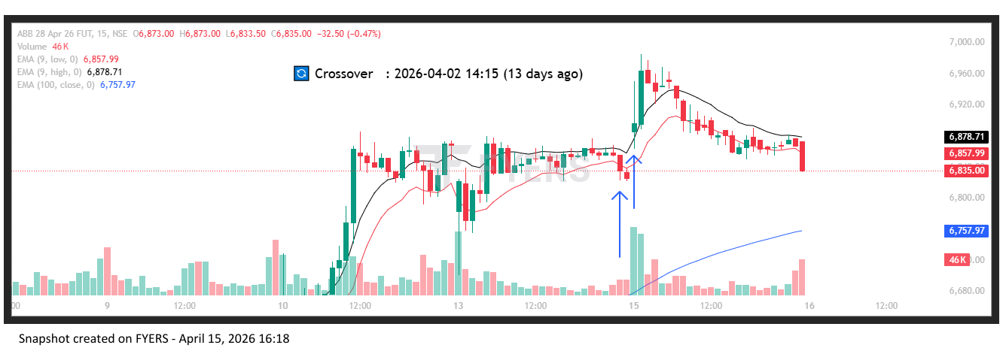
🟢 BULLISH SIGNAL --- AUBANK26AprFUT

Nifty Bias : ⚠️ CHOPPY — Choppy ⚠️
Crossover : 2026-04-06 12:45 (9 days ago)
Pullback : 2026-04-13 15:15
Low ₹977.35 ≤ EMA9(Low) ₹977.93
High ₹982.45 (breakout level)
Confirm : 2026-04-15 09:15 (+1 candle)
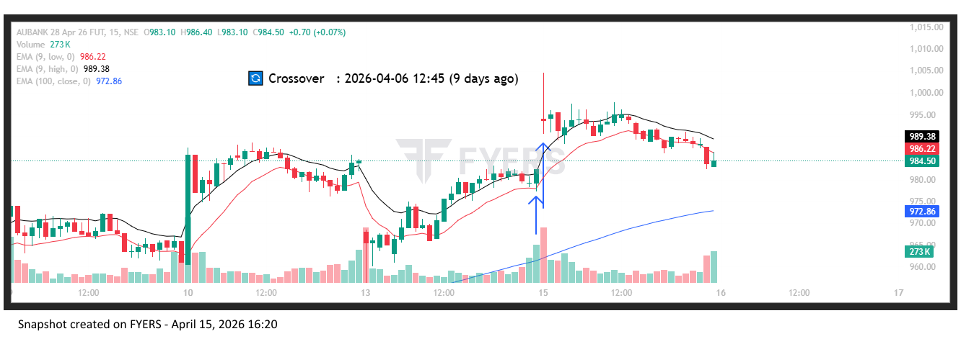
🟢 BULLISH SIGNAL --- ADANIENT26AprFUT

Nifty Bias : ⚠️ CHOPPY — Choppy ⚠️
Crossover : 2026-04-06 12:00 (9 days ago)
Pullback : 2026-04-13 14:45
Low ₹2134 ≤ EMA9(Low) ₹2137.59
High ₹2140 (breakout level)
Confirm : 2026-04-15 09:15 (+3 candle)
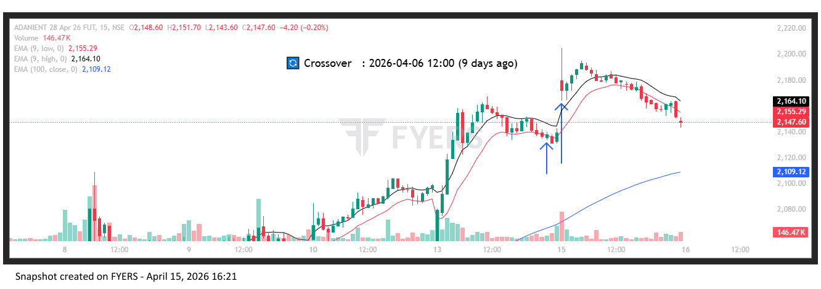
🟢 BULLISH SIGNAL --- ADANIGREEN26AprFUT

Nifty Bias : ⚠️ CHOPPY — Choppy ⚠️
Crossover : 2026-04-02 15:15 (13 days ago)
Pullback : 2026-04-13 15:00
Low ₹1084.95 ≤ EMA9(Low) ₹1086.19
High ₹1091 (breakout level)
Confirm : 2026-04-15 09:15 (+2 candle)
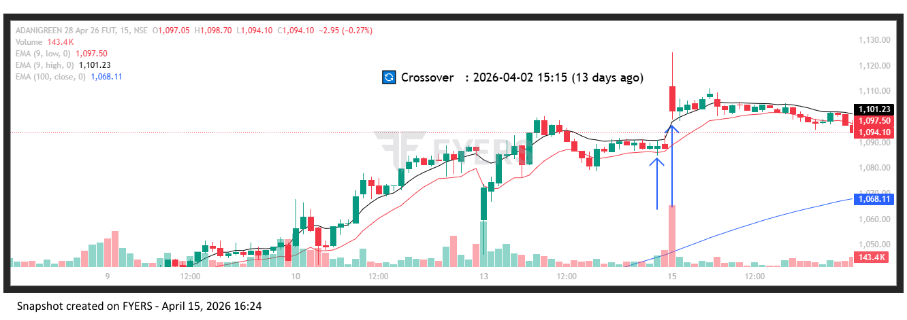
🟢 BULLISH SIGNAL --- ADANIPORTS26AprFUT

Nifty Bias : ⚠️ CHOPPY — Choppy ⚠️
Crossover : 2026-04-06 13:00 (9 days ago)
Pullback : 2026-04-13 14:45
Low ₹1467 ≤ EMA9(Low) ₹1470.18
High ₹1471.2 (breakout level)
Confirm : 2026-04-15 09:15 (+3 candle)
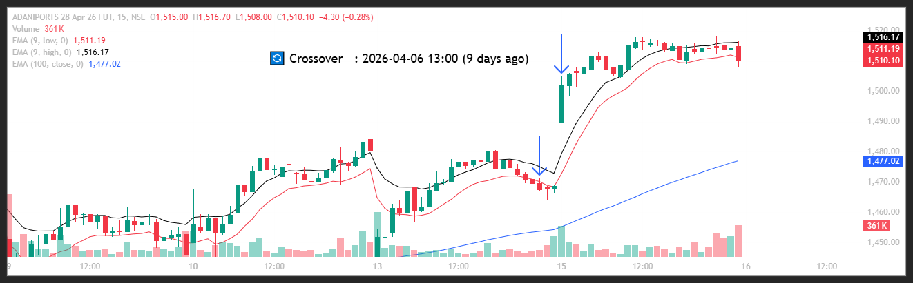
🟢 BULLISH SIGNAL --- ABCAPITAL26AprFUT

Nifty Bias : ⚠️ CHOPPY — Choppy ⚠️
Crossover : 2026-04-06 10:45 (9 days ago)
Pullback : 2026-04-13 15:15
Low ₹337.3 ≤ EMA9(Low) ₹337.94
High ₹340 (breakout level)
Confirm : 2026-04-15 09:15 (+1 candle)

🟢 BULLISH SIGNAL --- ALKEM26AprFUT

Nifty Bias : ⚠️ CHOPPY — Choppy ⚠️
Crossover : 2026-04-09 10:45 (6 days ago)
Pullback : 2026-04-13 15:00
Low ₹5377.5 ≤ EMA9(Low) ₹5386.64
High ₹5397 (breakout level)
Confirm : 2026-04-15 09:15 (+2 candle)

🟢 BULLISH SIGNAL --- AMBER26AprFUT

Nifty Bias : ⚠️ CHOPPY — Choppy ⚠️
Crossover : 2026-04-07 12:15 (8 days ago)
Pullback : 2026-04-13 15:00
Low ₹7162.5 ≤ EMA9(Low) ₹7181.34
High ₹7216 (breakout level)
Confirm : 2026-04-15 09:15 (+2 candle)

🟢 BULLISH SIGNAL --- AMBUJACEM26AprFUT

Nifty Bias : ⚠️ CHOPPY — Choppy ⚠️
Crossover : 2026-04-02 15:00 (13 days ago)
Pullback : 2026-04-13 15:00
Low ₹440.85 ≤ EMA9(Low) ₹441.35
High ₹443.5 (breakout level)
Confirm : 2026-04-15 09:15 (+2 candle)

🟢 BULLISH SIGNAL --- APOLLOHOSP26AprFUT

Nifty Bias : ⚠️ CHOPPY — Choppy ⚠️
Crossover : 2026-04-08 14:45 (7 days ago)
Pullback : 2026-04-13 15:00
Low ₹7520 ≤ EMA9(Low) ₹7522.09
High ₹7538 (breakout level)
Confirm : 2026-04-15 09:15 (+2 candle)

🟢 BULLISH SIGNAL --- ASHOKLEY26AprFUT

Nifty Bias : ⚠️ CHOPPY — Choppy ⚠️
Crossover : 2026-04-08 09:15 (7 days ago)
Pullback : 2026-04-13 15:00
Low ₹171.96 ≤ EMA9(Low) ₹172.19
High ₹172.68 (breakout level)
Confirm : 2026-04-15 09:15 (+2 candle)

🟢 BULLISH SIGNAL --- ASIANPAINT26AprFUT

Nifty Bias : ⚠️ CHOPPY — Choppy ⚠️
Crossover : 2026-04-08 09:15 (7 days ago)
Pullback : 2026-04-13 15:00
Low ₹2351.4 ≤ EMA9(Low) ₹2356.88
High ₹2362.2 (breakout level)
Confirm : 2026-04-15 09:15 (+2 candle)

🟢 BULLISH SIGNAL --- DMART26AprFUT

Nifty Bias : ⚠️ CHOPPY — Choppy ⚠️
Crossover : 2026-04-13 12:15 (2 days ago)
Pullback : 2026-04-13 14:45
Low ₹4442.8 ≤ EMA9(Low) ₹4443.99
High ₹4456.5 (breakout level)
Confirm : 2026-04-15 09:15 (+3 candle)

🟢 BULLISH SIGNAL --- AXISBANK26AprFUT

Nifty Bias : ⚠️ CHOPPY — Choppy ⚠️
Crossover : 2026-04-06 09:15 (9 days ago)
Pullback : 2026-04-13 15:00
Low ₹1353.1 ≤ EMA9(Low) ₹1355.61
High ₹1359.5 (breakout level)
Confirm : 2026-04-15 09:15 (+2 candle)

🟢 BULLISH SIGNAL --- BAJFINANCE26AprFUT

Nifty Bias : ⚠️ CHOPPY — Choppy ⚠️
Crossover : 2026-04-06 12:30 (9 days ago)
Pullback : 2026-04-13 15:00
Low ₹900.05 ≤ EMA9(Low) ₹901.24
High ₹905.15 (breakout level)
Confirm : 2026-04-15 09:15 (+2 candle)

🟢 BULLISH SIGNAL --- BDL26AprFUT

Nifty Bias : ⚠️ CHOPPY — Choppy ⚠️
Crossover : 2026-04-01 10:15 (14 days ago)
Pullback : 2026-04-13 15:15
Low ₹1334.4 ≤ EMA9(Low) ₹1335.21
High ₹1342 (breakout level)
Confirm : 2026-04-15 09:15 (+1 candle)

🟢 BULLISH SIGNAL --- BEL26AprFUT

Nifty Bias : ⚠️ CHOPPY — Choppy ⚠️
Crossover : 2026-04-02 13:30 (13 days ago)
Pullback : 2026-04-13 14:45
Low ₹444.1 ≤ EMA9(Low) ₹444.46
High ₹444.75 (breakout level)
Confirm : 2026-04-15 09:15 (+3 candle)

🟢 BULLISH SIGNAL --- BHARATFORG26AprFUT

Nifty Bias : ⚠️ CHOPPY — Choppy ⚠️
Crossover : 2026-04-07 15:15 (8 days ago)
Pullback : 2026-04-13 15:00
Low ₹1801.6 ≤ EMA9(Low) ₹1807.59
High ₹1811.2 (breakout level)
Confirm : 2026-04-15 09:15 (+2 candle)

🟢 BULLISH SIGNAL --- HINDZINC26AprFUT

Nifty Bias : ⚠️ CHOPPY — Choppy ⚠️
Crossover : 2026-04-06 09:30 (9 days ago)
Pullback : 2026-04-13 15:00
Low ₹561.6 ≤ EMA9(Low) ₹561.85
High ₹564.15 (breakout level)
Confirm : 2026-04-15 09:15 (+2 candle)

🟢 BULLISH SIGNAL --- POWERINDIA26AprFUT

Nifty Bias : ⚠️ CHOPPY — Choppy ⚠️
Crossover : 2026-04-08 09:15 (7 days ago)
Pullback : 2026-04-13 14:45
Low ₹28305 ≤ EMA9(Low) ₹28528.01
High ₹28550 (breakout level)
Confirm : 2026-04-15 09:15 (+3 candle)

🟢 BULLISH SIGNAL --- ICICIGI26AprFUT

Nifty Bias : ⚠️ CHOPPY — Choppy ⚠️
Crossover : 2026-04-07 12:15 (8 days ago)
Pullback : 2026-04-13 15:00
Low ₹1776.8 ≤ EMA9(Low) ₹1779.94
High ₹1791 (breakout level)
Confirm : 2026-04-15 09:15 (+2 candle)

🟢 BULLISH SIGNAL --- INDIANB26AprFUT

Nifty Bias : ⚠️ CHOPPY — Choppy ⚠️
Crossover : 2026-04-06 09:30 (9 days ago)
Pullback : 2026-04-13 15:15
Low ₹963.2 ≤ EMA9(Low) ₹965
High ₹971.3 (breakout level)
Confirm : 2026-04-15 09:15 (+1 candle)

🟢 BULLISH SIGNAL --- IEX26AprFUT

Nifty Bias : ⚠️ CHOPPY — Choppy ⚠️
Crossover : 2026-04-06 10:15 (9 days ago)
Pullback : 2026-04-13 15:00
Low ₹129.46 ≤ EMA9(Low) ₹129.73
High ₹129.88 (breakout level)
Confirm : 2026-04-15 09:15 (+2 candle)

🟢 BULLISH SIGNAL --- IREDA26AprFUT

Nifty Bias : ⚠️ CHOPPY — Choppy ⚠️
Crossover : 2026-04-06 10:45 (9 days ago)
Pullback : 2026-04-13 15:00
Low ₹123.1 ≤ EMA9(Low) ₹123.37
High ₹123.69 (breakout level)
Confirm : 2026-04-15 09:15 (+2 candle)

🟢 BULLISH SIGNAL --- INOXWIND26AprFUT

Nifty Bias : ⚠️ CHOPPY — Choppy ⚠️
Crossover : 2026-04-06 11:15 (9 days ago)
Pullback : 2026-04-13 14:45
Low ₹87.74 ≤ EMA9(Low) ₹87.81
High ₹87.98 (breakout level)
Confirm : 2026-04-15 09:15 (+3 candle)

🟢 BULLISH SIGNAL --- JINDALSTEL26AprFUT

Nifty Bias : ⚠️ CHOPPY — Choppy ⚠️
Crossover : 2026-04-07 10:45 (8 days ago)
Pullback : 2026-04-13 15:15
Low ₹1221 ≤ EMA9(Low) ₹1221.4
High ₹1225.8 (breakout level)
Confirm : 2026-04-15 09:15 (+1 candle)

🟢 BULLISH SIGNAL --- JSWENERGY26AprFUT

Nifty Bias : ⚠️ CHOPPY — Choppy ⚠️
Crossover : 2026-04-13 11:15 (2 days ago)
Pullback : 2026-04-13 15:15
Low ₹506.8 ≤ EMA9(Low) ₹507.35
High ₹516.4 (breakout level)
Confirm : 2026-04-15 09:15 (+1 candle)

🟢 BULLISH SIGNAL --- JSWSTEEL26AprFUT

Nifty Bias : ⚠️ CHOPPY — Choppy ⚠️
Crossover : 2026-04-07 14:00 (8 days ago)
Pullback : 2026-04-13 15:00
Low ₹1204.3 ≤ EMA9(Low) ₹1205.71
High ₹1209.4 (breakout level)
Confirm : 2026-04-15 09:15 (+2 candle)

🟢 BULLISH SIGNAL --- JUBLFOOD26AprFUT

Nifty Bias : ⚠️ CHOPPY — Choppy ⚠️
Crossover : 2026-04-10 11:00 (5 days ago)
Pullback : 2026-04-13 15:15
Low ₹436.15 ≤ EMA9(Low) ₹436.28
High ₹437.4 (breakout level)
Confirm : 2026-04-15 09:15 (+1 candle)

🟢 BULLISH SIGNAL --- KEI26AprFUT

Nifty Bias : ⚠️ CHOPPY — Choppy ⚠️
Crossover : 2026-04-06 10:30 (9 days ago)
Pullback : 2026-04-13 15:00
Low ₹4444.9 ≤ EMA9(Low) ₹4453.97
High ₹4471.3 (breakout level)
Confirm : 2026-04-15 09:15 (+2 candle)

🟢 BULLISH SIGNAL --- KALYANKJIL26AprFUT

Nifty Bias : ⚠️ CHOPPY — Choppy ⚠️
Crossover : 2026-04-02 14:30 (13 days ago)
Pullback : 2026-04-13 15:00
Low ₹442.2 ≤ EMA9(Low) ₹442.47
High ₹444.1 (breakout level)
Confirm : 2026-04-15 09:15 (+2 candle)

🟢 BULLISH SIGNAL --- KAYNES26AprFUT

Nifty Bias : ⚠️ CHOPPY — Choppy ⚠️
Crossover : 2026-04-06 12:00 (9 days ago)
Pullback : 2026-04-13 15:00
Low ₹3862.5 ≤ EMA9(Low) ₹3868.83
High ₹3887.1 (breakout level)
Confirm : 2026-04-15 09:15 (+2 candle)

🟢 BULLISH SIGNAL --- LTF26AprFUT

Nifty Bias : ⚠️ CHOPPY — Choppy ⚠️
Crossover : 2026-04-06 10:45 (9 days ago)
Pullback : 2026-04-13 14:45
Low ₹272.61 ≤ EMA9(Low) ₹274.46
High ₹274.74 (breakout level)
Confirm : 2026-04-15 09:15 (+3 candle)

🟢 BULLISH SIGNAL --- LT26AprFUT

Nifty Bias : ⚠️ CHOPPY — Choppy ⚠️
Crossover : 2026-04-02 14:45 (13 days ago)
Pullback : 2026-04-13 15:00
Low ₹3952 ≤ EMA9(Low) ₹3953.69
High ₹3962.1 (breakout level)
Confirm : 2026-04-15 09:15 (+2 candle)

🟢 BULLISH SIGNAL --- M&M26AprFUT

Nifty Bias : ⚠️ CHOPPY — Choppy ⚠️
Crossover : 2026-04-08 09:15 (7 days ago)
Pullback : 2026-04-13 15:00
Low ₹3221.9 ≤ EMA9(Low) ₹3231.18
High ₹3241.3 (breakout level)
Confirm : 2026-04-15 09:15 (+2 candle)

🟢 BULLISH SIGNAL --- MANKIND26AprFUT

Nifty Bias : ⚠️ CHOPPY — Choppy ⚠️
Crossover : 2026-04-06 14:15 (9 days ago)
Pullback : 2026-04-13 15:00
Low ₹2077.3 ≤ EMA9(Low) ₹2079.27
High ₹2084.6 (breakout level)
Confirm : 2026-04-15 09:15 (+2 candle)

🟢 BULLISH SIGNAL --- TMPV26AprFUT

Nifty Bias : ⚠️ CHOPPY — Choppy ⚠️
Crossover : 2026-04-07 13:30 (8 days ago)
Pullback : 2026-04-13 15:00
Low ₹343.75 ≤ EMA9(Low) ₹343.97
High ₹345.3 (breakout level)
Confirm : 2026-04-15 09:15 (+2 candle)

🟢 BULLISH SIGNAL --- TATATECH26AprFUT

Nifty Bias : ⚠️ CHOPPY — Choppy ⚠️
Crossover : 2026-04-02 13:45 (13 days ago)
Pullback : 2026-04-13 14:45
Low ₹562.3 ≤ EMA9(Low) ₹562.59
High ₹564.9 (breakout level)
Confirm : 2026-04-15 09:15 (+3 candle)

🟢 BULLISH SIGNAL --- FEDERALBNK26AprFUT

Nifty Bias : ⚠️ CHOPPY — Choppy ⚠️
Crossover : 2026-04-06 10:00 (9 days ago)
Pullback : 2026-04-13 14:45
Low ₹288.95 ≤ EMA9(Low) ₹289.03
High ₹289.9 (breakout level)
Confirm : 2026-04-15 09:15 (+3 candle)

🟢 BULLISH SIGNAL --- INDHOTEL26AprFUT

Nifty Bias : ⚠️ CHOPPY — Choppy ⚠️
Crossover : 2026-04-07 10:30 (8 days ago)
Pullback : 2026-04-13 15:00
Low ₹635.55 ≤ EMA9(Low) ₹637.93
High ₹639.05 (breakout level)
Confirm : 2026-04-15 09:15 (+2 candle)

🟢 BULLISH SIGNAL --- PHOENIXLTD26AprFUT

Nifty Bias : ⚠️ CHOPPY — Choppy ⚠️
Crossover : 2026-04-06 10:15 (9 days ago)
Pullback : 2026-04-13 14:45
Low ₹1759.4 ≤ EMA9(Low) ₹1759.87
High ₹1764.1 (breakout level)
Confirm : 2026-04-15 09:15 (+3 candle)

🟢 BULLISH SIGNAL --- TITAN26AprFUT

Nifty Bias : ⚠️ CHOPPY — Choppy ⚠️
Crossover : 2026-04-02 14:15 (13 days ago)
Pullback : 2026-04-13 14:45
Low ₹4461.1 ≤ EMA9(Low) ₹4473.27
High ₹4469.7 (breakout level)
Confirm : 2026-04-15 09:15 (+3 candle)

🟢 BULLISH SIGNAL --- TORNTPHARM26AprFUT

Nifty Bias : ⚠️ CHOPPY — Choppy ⚠️
Crossover : 2026-04-09 11:00 (6 days ago)
Pullback : 2026-04-13 14:45
Low ₹4174.5 ≤ EMA9(Low) ₹4184.52
High ₹4187.1 (breakout level)
Confirm : 2026-04-15 09:15 (+3 candle)

🟢 BULLISH SIGNAL --- TORNTPOWER26AprFUT

Nifty Bias : ⚠️ CHOPPY — Choppy ⚠️
Crossover : 2026-04-06 10:15 (9 days ago)
Pullback : 2026-04-13 15:15
Low ₹1476.5 ≤ EMA9(Low) ₹1478.92
High ₹1486.9 (breakout level)
Confirm : 2026-04-15 09:15 (+1 candle)

🟢 BULLISH SIGNAL --- TRENT26AprFUT

Nifty Bias : ⚠️ CHOPPY — Choppy ⚠️
Crossover : 2026-04-02 12:45 (13 days ago)
Pullback : 2026-04-13 15:00
Low ₹3864 ≤ EMA9(Low) ₹3869.02
High ₹3891.9 (breakout level)
Confirm : 2026-04-15 09:15 (+2 candle)

🟢 BULLISH SIGNAL --- TIINDIA26AprFUT

Nifty Bias : ⚠️ CHOPPY — Choppy ⚠️
Crossover : 2026-04-07 13:00 (8 days ago)
Pullback : 2026-04-13 15:00
Low ₹2722.1 ≤ EMA9(Low) ₹2729.48
High ₹2735.1 (breakout level)
Confirm : 2026-04-15 09:15 (+2 candle)

🟢 BULLISH SIGNAL --- IDEA26AprFUT

Nifty Bias : ⚠️ CHOPPY — Choppy ⚠️
Crossover : 2026-04-08 09:15 (7 days ago)
Pullback : 2026-04-13 15:15
Low ₹9.22 ≤ EMA9(Low) ₹9.27
High ₹9.31 (breakout level)
Confirm : 2026-04-15 09:15 (+1 candle)

🟢 BULLISH SIGNAL --- YESBANK26AprFUT

Nifty Bias : ⚠️ CHOPPY — Choppy ⚠️
Crossover : 2026-04-13 11:00 (2 days ago)
Pullback : 2026-04-13 15:00
Low ₹18.92 ≤ EMA9(Low) ₹18.93
High ₹18.97 (breakout level)
Confirm : 2026-04-15 09:15 (+2 candle)

🟢 BULLISH SIGNAL --- BHEL26AprFUT

Nifty Bias : 🟢 LONG — Aligned ✅
Crossover : 2026-04-07 13:45 (8 days ago)
Pullback : 2026-04-13 14:45
Low ₹288.72 ≤ EMA9(Low) ₹289.94
High ₹290.5 (breakout level)
Confirm : 2026-04-15 09:15 (+3 candle)

🟢 BULLISH SIGNAL --- BHARTIARTL26AprFUT

Nifty Bias : 🟢 LONG — Aligned ✅
Crossover : 2026-04-07 10:00 (8 days ago)
Pullback : 2026-04-13 14:45
Low ₹1878.1 ≤ EMA9(Low) ₹1879.37
High ₹1882.4 (breakout level)
Confirm : 2026-04-15 09:15 (+3 candle)

🟢 BULLISH SIGNAL --- BOSCHLTD26AprFUT

Nifty Bias : 🟢 LONG — Aligned ✅
Crossover : 2026-04-01 10:30 (14 days ago)
Pullback : 2026-04-13 14:45
Low ₹36745 ≤ EMA9(Low) ₹36752.61
High ₹36800 (breakout level)
Confirm : 2026-04-15 09:15 (+3 candle)

🟢 BULLISH SIGNAL --- BRITANNIA26AprFUT

Nifty Bias : 🟢 LONG — Aligned ✅
Crossover : 2026-04-13 11:45 (2 days ago)
Pullback : 2026-04-13 15:00
Low ₹5587.5 ≤ EMA9(Low) ₹5587.96
High ₹5612 (breakout level)
Confirm : 2026-04-15 09:15 (+2 candle)

🟢 BULLISH SIGNAL --- CDSL26AprFUT

Nifty Bias : 🟢 LONG — Aligned ✅
Crossover : 2026-04-06 10:15 (9 days ago)
Pullback : 2026-04-13 15:00
Low ₹1286.1 ≤ EMA9(Low) ₹1289.49
High ₹1293.1 (breakout level)
Confirm : 2026-04-15 09:15 (+2 candle)

🟢 BULLISH SIGNAL --- COLPAL26AprFUT

Nifty Bias : 🟢 LONG — Aligned ✅
Crossover : 2026-04-07 12:30 (8 days ago)
Pullback : 2026-04-13 15:00
Low ₹1913.3 ≤ EMA9(Low) ₹1917.14
High ₹1924.3 (breakout level)
Confirm : 2026-04-15 09:15 (+2 candle)

🟢 BULLISH SIGNAL --- CAMS26AprFUT

Nifty Bias : 🟢 LONG — Aligned ✅
Crossover : 2026-04-02 14:15 (13 days ago)
Pullback : 2026-04-13 15:00
Low ₹700.7 ≤ EMA9(Low) ₹701.87
High ₹704.5 (breakout level)
Confirm : 2026-04-15 09:15 (+2 candle)

🟢 BULLISH SIGNAL --- CONCOR26AprFUT

Nifty Bias : 🟢 LONG — Aligned ✅
Crossover : 2026-04-06 10:15 (9 days ago)
Pullback : 2026-04-13 15:00
Low ₹479.95 ≤ EMA9(Low) ₹480.25
High ₹482.85 (breakout level)
Confirm : 2026-04-15 09:15 (+2 candle)

🟢 BULLISH SIGNAL --- CUMMINSIND26AprFUT

Nifty Bias : 🟢 LONG — Aligned ✅
Crossover : 2026-04-02 14:30 (13 days ago)
Pullback : 2026-04-13 14:45
Low ₹5012 ≤ EMA9(Low) ₹5029.21
High ₹5027.4 (breakout level)
Confirm : 2026-04-15 09:15 (+3 candle)

🟢 BULLISH SIGNAL --- DLF26AprFUT

Nifty Bias : 🟢 LONG — Aligned ✅
Crossover : 2026-04-06 09:45 (9 days ago)
Pullback : 2026-04-13 15:00
Low ₹568.25 ≤ EMA9(Low) ₹568.25
High ₹570.25 (breakout level)
Confirm : 2026-04-15 09:15 (+2 candle)

🟢 BULLISH SIGNAL --- DALBHARAT26AprFUT

Nifty Bias : 🟢 LONG — Aligned ✅
Crossover : 2026-04-06 10:15 (9 days ago)
Pullback : 2026-04-13 14:45
Low ₹1950.3 ≤ EMA9(Low) ₹1951.16
High ₹1963.9 (breakout level)
Confirm : 2026-04-15 09:15 (+3 candle)

🟢 BULLISH SIGNAL --- DELHIVERY26AprFUT

Nifty Bias : 🟢 LONG — Aligned ✅
Crossover : 2026-04-06 10:45 (9 days ago)
Pullback : 2026-04-13 14:45
Low ₹466.75 ≤ EMA9(Low) ₹468.77
High ₹469.55 (breakout level)
Confirm : 2026-04-15 09:15 (+3 candle)

🟢 BULLISH SIGNAL --- DIVISLAB26AprFUT

Nifty Bias : 🟢 LONG — Aligned ✅
Crossover : 2026-04-09 11:30 (6 days ago)
Pullback : 2026-04-13 15:00
Low ₹6070 ≤ EMA9(Low) ₹6086.04
High ₹6104 (breakout level)
Confirm : 2026-04-15 09:15 (+2 candle)

🟢 BULLISH SIGNAL --- EXIDEIND26AprFUT

Nifty Bias : 🟢 LONG — Aligned ✅
Crossover : 2026-04-08 09:15 (7 days ago)
Pullback : 2026-04-13 14:45
Low ₹326.15 ≤ EMA9(Low) ₹326.31
High ₹327.25 (breakout level)
Confirm : 2026-04-15 09:15 (+3 candle)

🟢 BULLISH SIGNAL --- NYKAA26AprFUT

Nifty Bias : 🟢 LONG — Aligned ✅
Crossover : 2026-04-02 14:00 (13 days ago)
Pullback : 2026-04-13 14:45
Low ₹257.32 ≤ EMA9(Low) ₹257.8
High ₹258.22 (breakout level)
Confirm : 2026-04-15 09:15 (+3 candle)

🟢 BULLISH SIGNAL --- FORTIS26AprFUT

Nifty Bias : 🟢 LONG — Aligned ✅
Crossover : 2026-04-06 13:00 (9 days ago)
Pullback : 2026-04-13 14:45
Low ₹855 ≤ EMA9(Low) ₹856.13
High ₹857.9 (breakout level)
Confirm : 2026-04-15 09:15 (+3 candle)

🟢 BULLISH SIGNAL --- GODREJPROP26AprFUT

Nifty Bias : 🟢 LONG — Aligned ✅
Crossover : 2026-04-06 10:00 (9 days ago)
Pullback : 2026-04-13 14:45
Low ₹1713.1 ≤ EMA9(Low) ₹1713.54
High ₹1717.9 (breakout level)
Confirm : 2026-04-15 09:15 (+3 candle)

🟢 BULLISH SIGNAL --- HDFCAMC26AprFUT

Nifty Bias : 🟢 LONG — Aligned ✅
Crossover : 2026-04-02 13:30 (13 days ago)
Pullback : 2026-04-13 15:00
Low ₹2545 ≤ EMA9(Low) ₹2550.93
High ₹2559.1 (breakout level)
Confirm : 2026-04-15 09:15 (+2 candle)

🟢 BULLISH SIGNAL --- HDFCLIFE26AprFUT

Nifty Bias : 🟢 LONG — Aligned ✅
Crossover : 2026-04-10 09:30 (5 days ago)
Pullback : 2026-04-13 15:15
Low ₹620.15 ≤ EMA9(Low) ₹620.48
High ₹623 (breakout level)
Confirm : 2026-04-15 09:15 (+1 candle)

🟢 BULLISH SIGNAL --- HINDALCO26AprFUT

Nifty Bias : 🟢 LONG — Aligned ✅
Crossover : 2026-04-02 13:00 (13 days ago)
Pullback : 2026-04-13 15:15
Low ₹978.6 ≤ EMA9(Low) ₹979.46
High ₹981.7 (breakout level)
Confirm : 2026-04-15 09:15 (+1 candle)

🟢 BULLISH SIGNAL --- PAYTM26AprFUT

Nifty Bias : 🟢 LONG — Aligned ✅
Crossover : 2026-04-06 13:00 (9 days ago)
Pullback : 2026-04-13 15:00
Low ₹1105.6 ≤ EMA9(Low) ₹1106.73
High ₹1113 (breakout level)
Confirm : 2026-04-15 09:15 (+2 candle)

🟢 BULLISH SIGNAL --- OFSS26AprFUT

Nifty Bias : 🟢 LONG — Aligned ✅
Crossover : 2026-04-13 11:00 (2 days ago)
Pullback : 2026-04-13 15:00
Low ₹7157.5 ≤ EMA9(Low) ₹7169.91
High ₹7191.5 (breakout level)
Confirm : 2026-04-15 09:15 (+2 candle)

🟢 BULLISH SIGNAL --- PGEL26AprFUT

Nifty Bias : 🟢 LONG — Aligned ✅
Crossover : 2026-04-08 09:45 (7 days ago)
Pullback : 2026-04-13 15:15
Low ₹486.5 ≤ EMA9(Low) ₹486.7
High ₹490.4 (breakout level)
Confirm : 2026-04-15 09:15 (+1 candle)

🟢 BULLISH SIGNAL --- PAGEIND26AprFUT

Nifty Bias : 🟢 LONG — Aligned ✅
Crossover : 2026-04-01 10:15 (14 days ago)
Pullback : 2026-04-13 14:45
Low ₹36050 ≤ EMA9(Low) ₹36184.45
High ₹36165 (breakout level)
Confirm : 2026-04-15 09:15 (+3 candle)

🟢 BULLISH SIGNAL --- PERSISTENT26AprFUT

Nifty Bias : 🟢 LONG — Aligned ✅
Crossover : 2026-04-01 09:45 (14 days ago)
Pullback : 2026-04-13 14:45
Low ₹5373.1 ≤ EMA9(Low) ₹5374.08
High ₹5385.9 (breakout level)
Confirm : 2026-04-15 09:15 (+3 candle)

🔴 BEARISH SIGNAL --- PIDILITIND26AprFUT

Nifty Bias : 🟢 LONG — Counter Trend ⚠️
Crossover : 2026-04-13 12:00 (2 days ago)
Pullback : 2026-04-15 09:15
High ₹1354.8 ≥ EMA9(High) ₹1338.2
Low ₹1330.5 (breakdown level)
Confirm : 2026-04-15 09:30 (+1 candle)

🟢 BULLISH SIGNAL --- PPLPHARMA26AprFUT

Nifty Bias : 🟢 LONG — Aligned ✅
Crossover : 2026-04-06 14:30 (9 days ago)
Pullback : 2026-04-13 15:00
Low ₹145.44 ≤ EMA9(Low) ₹145.84
High ₹146.64 (breakout level)
Confirm : 2026-04-15 09:15 (+2 candle)

🟢 BULLISH SIGNAL --- PRESTIGE26AprFUT

Nifty Bias : 🟢 LONG — Aligned ✅
Crossover : 2026-04-06 12:30 (9 days ago)
Pullback : 2026-04-13 15:00
Low ₹1307.8 ≤ EMA9(Low) ₹1310.23
High ₹1314.8 (breakout level)
Confirm : 2026-04-15 09:15 (+2 candle)

🟢 BULLISH SIGNAL --- RECLTD26AprFUT

Nifty Bias : 🟢 LONG — Aligned ✅
Crossover : 2026-04-02 14:00 (13 days ago)
Pullback : 2026-04-13 15:00
Low ₹346.6 ≤ EMA9(Low) ₹347.04
High ₹348.45 (breakout level)
Confirm : 2026-04-15 09:15 (+2 candle)

🟢 BULLISH SIGNAL --- SBILIFE26AprFUT

Nifty Bias : 🟢 LONG — Aligned ✅
Crossover : 2026-04-06 13:00 (9 days ago)
Pullback : 2026-04-13 14:45
Low ₹1919.3 ≤ EMA9(Low) ₹1922.49
High ₹1923.1 (breakout level)
Confirm : 2026-04-15 09:15 (+3 candle)

🟢 BULLISH SIGNAL --- SHREECEM26AprFUT

Nifty Bias : 🟢 LONG — Aligned ✅
Crossover : 2026-04-13 11:00 (2 days ago)
Pullback : 2026-04-13 15:00
Low ₹24305 ≤ EMA9(Low) ₹24312.21
High ₹24375 (breakout level)
Confirm : 2026-04-15 09:15 (+2 candle)

🟢 BULLISH SIGNAL --- SRF26AprFUT

Nifty Bias : 🟢 LONG — Aligned ✅
Crossover : 2026-04-13 11:00 (2 days ago)
Pullback : 2026-04-13 15:00
Low ₹2448 ≤ EMA9(Low) ₹2456.81
High ₹2461 (breakout level)
Confirm : 2026-04-15 09:15 (+2 candle)

🟢 BULLISH SIGNAL --- SAMMAANCAP26AprFUT

Nifty Bias : 🟢 LONG — Aligned ✅
Crossover : 2026-04-08 10:15 (7 days ago)
Pullback : 2026-04-13 15:00
Low ₹153.8 ≤ EMA9(Low) ₹154.08
High ₹154.25 (breakout level)
Confirm : 2026-04-15 09:15 (+2 candle)

🟢 BULLISH SIGNAL --- MOTHERSON26AprFUT

Nifty Bias : 🟢 LONG — Aligned ✅
Crossover : 2026-04-07 12:00 (8 days ago)
Pullback : 2026-04-13 14:45
Low ₹118.55 ≤ EMA9(Low) ₹119.06
High ₹119.51 (breakout level)
Confirm : 2026-04-15 09:15 (+3 candle)

🟢 BULLISH SIGNAL --- SHRIRAMFIN26AprFUT

Nifty Bias : 🟢 LONG — Aligned ✅
Crossover : 2026-04-06 11:30 (9 days ago)
Pullback : 2026-04-13 14:45
Low ₹1007 ≤ EMA9(Low) ₹1008.85
High ₹1010.6 (breakout level)
Confirm : 2026-04-15 09:15 (+3 candle)

🟢 BULLISH SIGNAL --- SAIL26AprFUT

Nifty Bias : 🟢 LONG — Aligned ✅
Crossover : 2026-04-02 13:30 (13 days ago)
Pullback : 2026-04-13 14:45
Low ₹167.87 ≤ EMA9(Low) ₹168.81
High ₹169.53 (breakout level)
Confirm : 2026-04-15 09:15 (+3 candle)

🟢 BULLISH SIGNAL --- ASTRAL26AprFUT

Nifty Bias : 🟢 LONG — Aligned ✅
Crossover : 2026-04-09 11:15 (6 days ago)
Pullback : 2026-04-15 09:30
Low ₹1581.6 ≤ EMA9(Low) ₹1595.49
High ₹1597.6 (breakout level)
Confirm : 2026-04-15 09:45 (+1 candle)

🔴 BEARISH SIGNAL --- RELIANCE26AprFUT

Nifty Bias : 🟢 LONG — Counter Trend ⚠️
Crossover : 2026-04-13 09:45 (2 days ago)
Pullback : 2026-04-15 09:45
High ₹1344.9 ≥ EMA9(High) ₹1332.28
Low ₹1340.3 (breakdown level)
Confirm : 2026-04-15 10:00 (+1 candle)

🟢 BULLISH SIGNAL --- MUTHOOTFIN26AprFUT

Nifty Bias : 🟢 LONG — Aligned ✅
Crossover : 2026-04-06 13:15 (9 days ago)
Pullback : 2026-04-15 10:00
Low ₹3541.8 ≤ EMA9(Low) ₹3552.56
High ₹3577.5 (breakout level)
Confirm : 2026-04-15 10:30 (+2 candle)

🔴 BEARISH SIGNAL --- POLICYBZR26AprFUT

Nifty Bias : 🟢 LONG — Counter Trend ⚠️
Crossover : 2026-04-13 10:00 (2 days ago)
Pullback : 2026-04-15 10:15
High ₹1486.9 ≥ EMA9(High) ₹1482.22
Low ₹1485.1 (breakdown level)
Confirm : 2026-04-15 10:45 (+2 candle)

🔴 BEARISH SIGNAL --- SUNPHARMA26AprFUT

Nifty Bias : 🟢 LONG — Counter Trend ⚠️
Crossover : 2026-04-10 09:30 (5 days ago)
Pullback : 2026-04-15 10:45
High ₹1683 ≥ EMA9(High) ₹1674.01
Low ₹1677.3 (breakdown level)
Confirm : 2026-04-15 11:00 (+1 candle)

🟢 BULLISH SIGNAL --- HCLTECH26AprFUT

Nifty Bias : 🟢 LONG — Aligned ✅
Crossover : 2026-04-15 09:30 (2 hours ago)
Pullback : 2026-04-15 11:00
Low ₹1418 ≤ EMA9(Low) ₹1418.16
High ₹1422.3 (breakout level)
Confirm : 2026-04-15 11:15 (+1 candle)

🟢 BULLISH SIGNAL --- CANBK26AprFUT

Nifty Bias : 🟢 LONG — Aligned ✅
Crossover : 2026-04-06 12:00 (9 days ago)
Pullback : 2026-04-15 11:15
Low ₹140.9 ≤ EMA9(Low) ₹141.12
High ₹141.49 (breakout level)
Confirm : 2026-04-15 11:30 (+1 candle)

🟢 BULLISH SIGNAL --- PNB26AprFUT

Nifty Bias : 🟢 LONG — Aligned ✅
Crossover : 2026-04-13 12:00 (2 days ago)
Pullback : 2026-04-15 11:15
Low ₹112.61 ≤ EMA9(Low) ₹112.62
High ₹113.12 (breakout level)
Confirm : 2026-04-15 11:30 (+1 candle)

🟢 BULLISH SIGNAL --- ICICIBANK26AprFUT

Nifty Bias : 🟢 LONG — Aligned ✅
Crossover : 2026-04-06 13:45 (9 days ago)
Pullback : 2026-04-15 11:00
Low ₹1338.6 ≤ EMA9(Low) ₹1344.64
High ₹1343.4 (breakout level)
Confirm : 2026-04-15 11:45 (+3 candle)

🟢 BULLISH SIGNAL --- UNIONBANK26AprFUT

Nifty Bias : 🟢 LONG — Aligned ✅
Crossover : 2026-04-13 14:30 (2 days ago)
Pullback : 2026-04-15 11:15
Low ₹185.11 ≤ EMA9(Low) ₹186.03
High ₹186.21 (breakout level)
Confirm : 2026-04-15 11:45 (+2 candle)

🟢 BULLISH SIGNAL --- VEDL26AprFUT

Nifty Bias : 🟢 LONG — Aligned ✅
Crossover : 2026-04-02 13:30 (13 days ago)
Pullback : 2026-04-15 11:15
Low ₹755.7 ≤ EMA9(Low) ₹758.56
High ₹759.4 (breakout level)
Confirm : 2026-04-15 11:45 (+2 candle)

🟢 BULLISH SIGNAL --- BANKBARODA26AprFUT

Nifty Bias : 🟢 LONG — Aligned ✅
Crossover : 2026-04-13 12:30 (2 days ago)
Pullback : 2026-04-15 11:15
Low ₹278.6 ≤ EMA9(Low) ₹278.69
High ₹279.76 (breakout level)
Confirm : 2026-04-15 12:00 (+3 candle)

🟢 BULLISH SIGNAL --- BANKINDIA26AprFUT

Nifty Bias : 🟢 LONG — Aligned ✅
Crossover : 2026-04-15 09:15 (3 hours ago)
Pullback : 2026-04-15 11:15
Low ₹147.3 ≤ EMA9(Low) ₹147.32
High ₹147.85 (breakout level)
Confirm : 2026-04-15 12:00 (+3 candle)

🔴 BEARISH SIGNAL --- DRREDDY26AprFUT

Nifty Bias : 🟢 LONG — Counter Trend ⚠️
Crossover : 2026-04-15 10:30 (2 hours ago)
Pullback : 2026-04-15 11:45
High ₹1217.9 ≥ EMA9(High) ₹1216.57
Low ₹1214 (breakdown level)
Confirm : 2026-04-15 12:00 (+1 candle)

🟢 BULLISH SIGNAL --- RBLBANK26AprFUT

Nifty Bias : 🟢 LONG — Aligned ✅
Crossover : 2026-04-15 09:45 (3 hours ago)
Pullback : 2026-04-15 11:30
Low ₹319.25 ≤ EMA9(Low) ₹319.8
High ₹320.05 (breakout level)
Confirm : 2026-04-15 12:00 (+2 candle)

🟢 BULLISH SIGNAL --- SBIN26AprFUT

Nifty Bias : 🟢 LONG — Aligned ✅
Crossover : 2026-04-13 13:30 (2 days ago)
Pullback : 2026-04-15 11:30
Low ₹1069.75 ≤ EMA9(Low) ₹1071.77
High ₹1073.55 (breakout level)
Confirm : 2026-04-15 12:00 (+2 candle)

🟢 BULLISH SIGNAL --- BIOCON26AprFUT

Nifty Bias : 🟢 LONG — Aligned ✅
Crossover : 2026-04-15 10:00 (3 hours ago)
Pullback : 2026-04-15 12:15
Low ₹350.25 ≤ EMA9(Low) ₹350.47
High ₹351.75 (breakout level)
Confirm : 2026-04-15 12:30 (+1 candle)

🟢 BULLISH SIGNAL --- ICICIPRULI26AprFUT

Nifty Bias : 🟢 LONG — Aligned ✅
Crossover : 2026-04-07 13:45 (8 days ago)
Pullback : 2026-04-15 12:15
Low ₹561.65 ≤ EMA9(Low) ₹562.52
High ₹563.2 (breakout level)
Confirm : 2026-04-15 12:45 (+2 candle)

🟢 BULLISH SIGNAL --- UNOMINDA26AprFUT

Nifty Bias : 🟢 LONG — Aligned ✅
Crossover : 2026-04-15 09:15 (4 hours ago)
Pullback : 2026-04-15 12:30
Low ₹1096.9 ≤ EMA9(Low) ₹1097.99
High ₹1098.3 (breakout level)
Confirm : 2026-04-15 12:45 (+1 candle)

🟢 BULLISH SIGNAL --- HDFCBANK26AprFUT

Nifty Bias : ⚠️ CHOPPY — Choppy ⚠️
Crossover : 2026-04-15 09:15 (4 hours ago)
Pullback : 2026-04-15 12:15
Low ₹809 ≤ EMA9(Low) ₹809.19
High ₹811.4 (breakout level)
Confirm : 2026-04-15 13:00 (+3 candle)

🟢 BULLISH SIGNAL --- INDUSINDBK26AprFUT

Nifty Bias : ⚠️ CHOPPY — Choppy ⚠️
Crossover : 2026-04-15 09:15 (4 hours ago)
Pullback : 2026-04-15 12:45
Low ₹835.05 ≤ EMA9(Low) ₹835.7
High ₹837.7 (breakout level)
Confirm : 2026-04-15 13:00 (+1 candle)

🟢 BULLISH SIGNAL --- LICHSGFIN26AprFUT

Nifty Bias : ⚠️ CHOPPY — Choppy ⚠️
Crossover : 2026-04-15 10:15 (3 hours ago)
Pullback : 2026-04-15 12:45
Low ₹527.9 ≤ EMA9(Low) ₹528.77
High ₹528.65 (breakout level)
Confirm : 2026-04-15 13:00 (+1 candle)

🟢 BULLISH SIGNAL --- PNBHOUSING26AprFUT

Nifty Bias : ⚠️ CHOPPY — Choppy ⚠️
Crossover : 2026-04-15 09:45 (4 hours ago)
Pullback : 2026-04-15 12:30
Low ₹861.1 ≤ EMA9(Low) ₹863.33
High ₹863 (breakout level)
Confirm : 2026-04-15 13:00 (+2 candle)

🟢 BULLISH SIGNAL --- CIPLA26AprFUT

Nifty Bias : 🟢 LONG — Aligned ✅
Crossover : 2026-04-15 10:30 (3 hours ago)
Pullback : 2026-04-15 13:00
Low ₹1225.7 ≤ EMA9(Low) ₹1226.22
High ₹1227.5 (breakout level)
Confirm : 2026-04-15 13:15 (+1 candle)

🟢 BULLISH SIGNAL --- GRASIM26AprFUT

Nifty Bias : 🟢 LONG — Aligned ✅
Crossover : 2026-04-15 09:15 (4 hours ago)
Pullback : 2026-04-15 12:45
Low ₹2755.5 ≤ EMA9(Low) ₹2755.72
High ₹2760.4 (breakout level)
Confirm : 2026-04-15 13:15 (+2 candle)

🟢 BULLISH SIGNAL --- MANAPPURAM26AprFUT

Nifty Bias : 🟢 LONG — Aligned ✅
Crossover : 2026-04-13 11:00 (2 days ago)
Pullback : 2026-04-15 12:45
Low ₹269.05 ≤ EMA9(Low) ₹270.42
High ₹269.8 (breakout level)
Confirm : 2026-04-15 13:15 (+2 candle)

🔴 BEARISH SIGNAL --- OIL26AprFUT

Nifty Bias : 🟢 LONG — Counter Trend ⚠️
Crossover : 2026-04-15 10:15 (3 hours ago)
Pullback : 2026-04-15 13:00
High ₹469.2 ≥ EMA9(High) ₹466.89
Low ₹467 (breakdown level)
Confirm : 2026-04-15 13:15 (+1 candle)

🟢 BULLISH SIGNAL --- PFC26AprFUT

Nifty Bias : 🟢 LONG — Aligned ✅
Crossover : 2026-04-02 14:15 (13 days ago)
Pullback : 2026-04-15 13:00
Low ₹441.45 ≤ EMA9(Low) ₹441.84
High ₹443 (breakout level)
Confirm : 2026-04-15 13:15 (+1 candle)

🟢 BULLISH SIGNAL --- SBICARD26AprFUT

Nifty Bias : 🟢 LONG — Aligned ✅
Crossover : 2026-04-07 15:00 (8 days ago)
Pullback : 2026-04-15 13:00
Low ₹686.3 ≤ EMA9(Low) ₹686.4
High ₹686.8 (breakout level)
Confirm : 2026-04-15 13:15 (+1 candle)

🟢 BULLISH SIGNAL --- TATASTEEL26AprFUT

Nifty Bias : 🟢 LONG — Aligned ✅
Crossover : 2026-04-13 11:30 (2 days ago)
Pullback : 2026-04-15 13:00
Low ₹208.02 ≤ EMA9(Low) ₹208.45
High ₹208.61 (breakout level)
Confirm : 2026-04-15 13:15 (+1 candle)

🟢 BULLISH SIGNAL --- BAJAJFINSV26AprFUT

Nifty Bias : 🟢 LONG — Aligned ✅
Crossover : 2026-04-07 11:45 (8 days ago)
Pullback : 2026-04-15 13:15
Low ₹1819.2 ≤ EMA9(Low) ₹1824.31
High ₹1823.3 (breakout level)
Confirm : 2026-04-15 13:30 (+1 candle)

🟢 BULLISH SIGNAL --- BPCL26AprFUT

Nifty Bias : 🟢 LONG — Aligned ✅
Crossover : 2026-04-15 09:30 (4 hours ago)
Pullback : 2026-04-15 13:00
Low ₹305.8 ≤ EMA9(Low) ₹305.88
High ₹306.45 (breakout level)
Confirm : 2026-04-15 13:30 (+2 candle)

🟢 BULLISH SIGNAL --- ETERNAL26AprFUT

Nifty Bias : 🟢 LONG — Aligned ✅
Crossover : 2026-04-15 10:00 (4 hours ago)
Pullback : 2026-04-15 13:00
Low ₹244.91 ≤ EMA9(Low) ₹244.96
High ₹245.5 (breakout level)
Confirm : 2026-04-15 13:30 (+2 candle)

🟢 BULLISH SIGNAL --- NUVAMA26AprFUT

Nifty Bias : 🟢 LONG — Aligned ✅
Crossover : 2026-04-06 10:15 (9 days ago)
Pullback : 2026-04-15 13:00
Low ₹1334 ≤ EMA9(Low) ₹1334.22
High ₹1335.4 (breakout level)
Confirm : 2026-04-15 13:30 (+2 candle)

🟢 BULLISH SIGNAL --- BAJAJ-AUTO26AprFUT

Nifty Bias : 🟢 LONG — Aligned ✅
Crossover : 2026-04-06 11:15 (9 days ago)
Pullback : 2026-04-15 13:00
Low ₹9854 ≤ EMA9(Low) ₹9883.05
High ₹9886.5 (breakout level)
Confirm : 2026-04-15 13:45 (+3 candle)

🟢 BULLISH SIGNAL --- IOC26AprFUT

Nifty Bias : 🟢 LONG — Aligned ✅
Crossover : 2026-04-15 09:15 (5 hours ago)
Pullback : 2026-04-15 13:30
Low ₹145.18 ≤ EMA9(Low) ₹145.25
High ₹145.5 (breakout level)
Confirm : 2026-04-15 13:45 (+1 candle)

🟢 BULLISH SIGNAL --- VOLTAS26AprFUT

Nifty Bias : 🟢 LONG — Aligned ✅
Crossover : 2026-04-08 10:00 (7 days ago)
Pullback : 2026-04-15 13:30
Low ₹1382.1 ≤ EMA9(Low) ₹1387.41
High ₹1388.4 (breakout level)
Confirm : 2026-04-15 13:45 (+1 candle)

🟢 BULLISH SIGNAL --- APLAPOLLO26AprFUT

Nifty Bias : 🟢 LONG — Aligned ✅
Crossover : 2026-04-15 11:30 (3 hours ago)
Pullback : 2026-04-15 13:45
Low ₹2030 ≤ EMA9(Low) ₹2030.51
High ₹2037.1 (breakout level)
Confirm : 2026-04-15 14:00 (+1 candle)

🟢 BULLISH SIGNAL --- CHOLAFIN26AprFUT

Nifty Bias : 🟢 LONG — Aligned ✅
Crossover : 2026-04-15 09:30 (5 hours ago)
Pullback : 2026-04-15 13:15
Low ₹1546.2 ≤ EMA9(Low) ₹1549.02
High ₹1551.7 (breakout level)
Confirm : 2026-04-15 14:00 (+3 candle)

🟢 BULLISH SIGNAL --- GODREJCP26AprFUT

Nifty Bias : 🟢 LONG — Aligned ✅
Crossover : 2026-04-15 09:30 (5 hours ago)
Pullback : 2026-04-15 13:45
Low ₹1088.6 ≤ EMA9(Low) ₹1088.85
High ₹1090.95 (breakout level)
Confirm : 2026-04-15 14:00 (+1 candle)

🟢 BULLISH SIGNAL --- ANGELONE26AprFUT

Nifty Bias : 🟢 LONG — Aligned ✅
Crossover : 2026-04-02 14:00 (13 days ago)
Pullback : 2026-04-15 14:00
Low ₹293.1 ≤ EMA9(Low) ₹293.17
High ₹293.87 (breakout level)
Confirm : 2026-04-15 14:15 (+1 candle)

🟢 BULLISH SIGNAL --- AUROPHARMA26AprFUT

Nifty Bias : 🟢 LONG — Aligned ✅
Crossover : 2026-04-15 09:30 (5 hours ago)
Pullback : 2026-04-15 13:45
Low ₹1368.1 ≤ EMA9(Low) ₹1368.55
High ₹1369.9 (breakout level)
Confirm : 2026-04-15 14:15 (+2 candle)

🟢 BULLISH SIGNAL --- INFY26AprFUT

Nifty Bias : 🟢 LONG — Aligned ✅
Crossover : 2026-04-15 10:30 (4 hours ago)
Pullback : 2026-04-15 13:30
Low ₹1299.4 ≤ EMA9(Low) ₹1299.62
High ₹1302.5 (breakout level)
Confirm : 2026-04-15 14:15 (+3 candle)

🟢 BULLISH SIGNAL --- NESTLEIND26AprFUT

Nifty Bias : 🟢 LONG — Aligned ✅
Crossover : 2026-04-15 09:15 (5 hours ago)
Pullback : 2026-04-15 14:00
Low ₹1246.3 ≤ EMA9(Low) ₹1247.64
High ₹1254.9 (breakout level)
Confirm : 2026-04-15 14:15 (+1 candle)

🟢 BULLISH SIGNAL --- SOLARINDS26AprFUT

Nifty Bias : 🟢 LONG — Aligned ✅
Crossover : 2026-04-02 12:15 (13 days ago)
Pullback : 2026-04-15 13:30
Low ₹14823 ≤ EMA9(Low) ₹14842.74
High ₹14863 (breakout level)
Confirm : 2026-04-15 14:15 (+3 candle)

🟢 BULLISH SIGNAL --- UNITDSPR26AprFUT

Nifty Bias : 🟢 LONG — Aligned ✅
Crossover : 2026-04-15 12:15 (2 hours ago)
Pullback : 2026-04-15 14:00
Low ₹1253.2 ≤ EMA9(Low) ₹1253.9
High ₹1257.5 (breakout level)
Confirm : 2026-04-15 14:15 (+1 candle)

🟢 BULLISH SIGNAL --- 360ONE26AprFUT

Nifty Bias : 🟢 LONG — Aligned ✅
Crossover : 2026-04-08 09:45 (7 days ago)
Pullback : 2026-04-15 13:45
Low ₹1045.8 ≤ EMA9(Low) ₹1048.8
High ₹1052.1 (breakout level)
Confirm : 2026-04-15 14:30 (+3 candle)

🟢 BULLISH SIGNAL --- ADANIENSOL26AprFUT

Nifty Bias : 🟢 LONG — Aligned ✅
Crossover : 2026-04-06 10:45 (9 days ago)
Pullback : 2026-04-15 13:45
Low ₹1173.5 ≤ EMA9(Low) ₹1178.19
High ₹1176.15 (breakout level)
Confirm : 2026-04-15 14:30 (+3 candle)

🟢 BULLISH SIGNAL --- RVNL26AprFUT

Nifty Bias : 🟢 LONG — Aligned ✅
Crossover : 2026-04-13 11:45 (2 days ago)
Pullback : 2026-04-15 14:15
Low ₹282.8 ≤ EMA9(Low) ₹282.93
High ₹283.98 (breakout level)
Confirm : 2026-04-15 14:30 (+1 candle)

🟢 BULLISH SIGNAL --- DABUR26AprFUT

Nifty Bias : 🟢 LONG — Aligned ✅
Crossover : 2026-04-15 10:00 (5 hours ago)
Pullback : 2026-04-15 14:00
Low ₹432.25 ≤ EMA9(Low) ₹433.39
High ₹432.95 (breakout level)
Confirm : 2026-04-15 14:45 (+3 candle)

🟢 BULLISH SIGNAL --- GAIL26AprFUT

Nifty Bias : 🟢 LONG — Aligned ✅
Crossover : 2026-04-02 14:15 (13 days ago)
Pullback : 2026-04-15 14:15
Low ₹155.56 ≤ EMA9(Low) ₹156.12
High ₹156.25 (breakout level)
Confirm : 2026-04-15 14:45 (+2 candle)

🟢 BULLISH SIGNAL --- JIOFIN26AprFUT

Nifty Bias : 🟢 LONG — Aligned ✅
Crossover : 2026-04-15 09:45 (5 hours ago)
Pullback : 2026-04-15 14:30
Low ₹243.45 ≤ EMA9(Low) ₹243.57
High ₹243.73 (breakout level)
Confirm : 2026-04-15 14:45 (+1 candle)

🟢 BULLISH SIGNAL --- KPITTECH26AprFUT

Nifty Bias : 🟢 LONG — Aligned ✅
Crossover : 2026-04-15 09:15 (6 hours ago)
Pullback : 2026-04-15 14:30
Low ₹731.35 ≤ EMA9(Low) ₹731.57
High ₹733 (breakout level)
Confirm : 2026-04-15 14:45 (+1 candle)

🟢 BULLISH SIGNAL --- ONGC26AprFUT

Nifty Bias : 🟢 LONG — Aligned ✅
Crossover : 2026-04-15 11:15 (4 hours ago)
Pullback : 2026-04-15 14:15
Low ₹287 ≤ EMA9(Low) ₹287.99
High ₹287.5 (breakout level)
Confirm : 2026-04-15 14:45 (+2 candle)

🔴 BEARISH SIGNAL --- COALINDIA26AprFUT

Nifty Bias : 🟢 LONG — Counter Trend ⚠️
Crossover : 2026-04-10 13:00 (5 days ago)
Pullback : 2026-04-15 14:45
High ₹435.75 ≥ EMA9(High) ₹435.14
Low ₹434.95 (breakdown level)
Confirm : 2026-04-15 15:00 (+1 candle)

📊 TRADING SUMMARY
━━ ALL TRADES (15-Apr) ━━━━━━━━━━━━━━━━━━━━
Total Signals | 150
Taken Trades | 11
Not Taken | 139
Balance | Rs. 1,09,75,128.40
Current Balance | Rs. 1,09,91,119.19

━━ TODAY'S LIVE TRADING (15-Apr) ━━━━━━━━━━━━━━━━━━━━
Total | 11
Completed | 11
Wins ✅ | 5
Losses ❌ | 6
Open ⏳ | 0
Win Rate | 45.5%
Net P/L | +Rs. 8,392.45 , +0.00 pts
Brokerage | Rs. 440.00
Taxes & Fees | Rs. 1836.55

━━ ALL-TIME LIVE TRADING ━━━━━━━━━━━━━━━━━━━━
Completed | 112
Wins ✅ | 60
Losses ❌ | 52
Open ⏳ | 4
Win Rate | 53.6%
Net P/L | +Rs. 15,990.76 , -82,113.75 pts
Brokerage | Rs. 4480.00
Taxes & Fees | Rs. 18451.44

━━ TODAY'S BACKTEST (15-Apr) ━━━━━━━━━━━━━━━━━━━━
Signals Today | 150
Resolved | 128
TARGET HIT ✅ | 74
SL HIT ❌ | 54
Open ⏳ | 22
Win Rate | 57.8%
Total PnL | -283.37 pts

━━ ALL-TIME BACKTEST SUMMARY ━━━━━━━━━━━━━━━━━━━━
Total Signals | 2060
TARGET HIT ✅ | 1032
SL HIT ❌ | 1006
Open ⏳ | 22
Win Rate | 50.6%
Total PnL | +5,822.13 pts

🤖 TRADE BEHAVIOUR ANALYSIS
✅ Trades Taken — What signals fired:
1. BSE26AprFUT — Bullish crossover, Nifty choppy. Entry ₹3367, SL ₹3320.5.
2. BANDHANBNK26AprFUT — Bullish crossover, Nifty choppy. Entry ₹170.4, SL ₹166.33.
3. LAURUSLABS26AprFUT — Bullish crossover, Nifty choppy. Entry ₹1113.7, SL ₹1090.
4. LODHA26AprFUT — Bullish crossover, Nifty choppy. Entry ₹842.55, SL ₹821.
5. TATAPOWER26AprFUT — Bullish crossover, Nifty choppy. Entry ₹411.45, SL ₹411.5.
6. VBL26AprFUT — Bullish crossover, Nifty choppy. Entry ₹441.05, SL ₹430.55.
7. ZYDUSLIFE26AprFUT — Bullish crossover, Nifty choppy. Entry ₹926.05, SL ₹925.35.
8. PIIND26AprFUT — Bullish crossover, aligned with Nifty bias. Entry ₹2946.2, SL ₹2920.1.
9. POLYCAB26AprFUT — Bullish crossover, aligned with Nifty bias. Entry ₹7738, SL ₹7563.
10. SIEMENS26AprFUT — Bullish crossover, aligned with Nifty bias. Entry ₹3425.5, SL ₹3364.
11. SUZLON26AprFUT — Bullish crossover, aligned with Nifty bias. Entry ₹47.53, SL ₹45.87.
⛔ Trades Not Taken (139 signals skipped):
Counter-trend to Nifty bias — skipped (7): PIDILITIND26AprFUT, RELIANCE26AprFUT, POLICYBZR26AprFUT, SUNPHARMA26AprFUT, DRREDDY26AprFUT, OIL26AprFUT, COALINDIA26AprFUT
Nifty choppy — skipped (52): ABB26AprFUT, AUBANK26AprFUT, ADANIENT26AprFUT, ADANIGREEN26AprFUT, ADANIPORTS26AprFUT, ABCAPITAL26AprFUT, ALKEM26AprFUT, AMBER26AprFUT, AMBUJACEM26AprFUT, APOLLOHOSP26AprFUT, ASHOKLEY26AprFUT, ASIANPAINT26AprFUT, DMART26AprFUT, AXISBANK26AprFUT, BAJFINANCE26AprFUT, BDL26AprFUT, BEL26AprFUT, BHARATFORG26AprFUT, HINDZINC26AprFUT, POWERINDIA26AprFUT, ICICIGI26AprFUT, INDIANB26AprFUT, IEX26AprFUT, IREDA26AprFUT, INOXWIND26AprFUT, JINDALSTEL26AprFUT, JSWENERGY26AprFUT, JSWSTEEL26AprFUT, JUBLFOOD26AprFUT, KEI26AprFUT, KALYANKJIL26AprFUT, KAYNES26AprFUT, LTF26AprFUT, LT26AprFUT, M&M26AprFUT, MANKIND26AprFUT, TMPV26AprFUT, TATATECH26AprFUT, FEDERALBNK26AprFUT, INDHOTEL26AprFUT, PHOENIXLTD26AprFUT, TITAN26AprFUT, TORNTPHARM26AprFUT, TORNTPOWER26AprFUT, TRENT26AprFUT, TIINDIA26AprFUT, IDEA26AprFUT, YESBANK26AprFUT, HDFCBANK26AprFUT, INDUSINDBK26AprFUT, LICHSGFIN26AprFUT, PNBHOUSING26AprFUT
Aligned but not entered (80): BHEL26AprFUT, BHARTIARTL26AprFUT, BOSCHLTD26AprFUT, BRITANNIA26AprFUT, CDSL26AprFUT, COLPAL26AprFUT, CAMS26AprFUT, CONCOR26AprFUT, CUMMINSIND26AprFUT, DLF26AprFUT, DALBHARAT26AprFUT, DELHIVERY26AprFUT, DIVISLAB26AprFUT, EXIDEIND26AprFUT, NYKAA26AprFUT, FORTIS26AprFUT, GODREJPROP26AprFUT, HDFCAMC26AprFUT, HDFCLIFE26AprFUT, HINDALCO26AprFUT, PAYTM26AprFUT, OFSS26AprFUT, PGEL26AprFUT, PAGEIND26AprFUT, PERSISTENT26AprFUT, PPLPHARMA26AprFUT, PRESTIGE26AprFUT, RECLTD26AprFUT, SBILIFE26AprFUT, SHREECEM26AprFUT, SRF26AprFUT, SAMMAANCAP26AprFUT, MOTHERSON26AprFUT, SHRIRAMFIN26AprFUT, SAIL26AprFUT, ASTRAL26AprFUT, MUTHOOTFIN26AprFUT, HCLTECH26AprFUT, CANBK26AprFUT, PNB26AprFUT, ICICIBANK26AprFUT, UNIONBANK26AprFUT, VEDL26AprFUT, BANKBARODA26AprFUT, BANKINDIA26AprFUT, RBLBANK26AprFUT, SBIN26AprFUT, BIOCON26AprFUT, ICICIPRULI26AprFUT, UNOMINDA26AprFUT, CIPLA26AprFUT, GRASIM26AprFUT, MANAPPURAM26AprFUT, PFC26AprFUT, SBICARD26AprFUT, TATASTEEL26AprFUT, BAJAJFINSV26AprFUT, BPCL26AprFUT, ETERNAL26AprFUT, NUVAMA26AprFUT, BAJAJ-AUTO26AprFUT, IOC26AprFUT, VOLTAS26AprFUT, APLAPOLLO26AprFUT, CHOLAFIN26AprFUT, GODREJCP26AprFUT, ANGELONE26AprFUT, AUROPHARMA26AprFUT, INFY26AprFUT, NESTLEIND26AprFUT, SOLARINDS26AprFUT, UNITDSPR26AprFUT, 360ONE26AprFUT, ADANIENSOL26AprFUT, RVNL26AprFUT, DABUR26AprFUT, GAIL26AprFUT, JIOFIN26AprFUT, KPITTECH26AprFUT, ONGC26AprFUT
📝 93% of today's signals were not acted on. 7 were counter-trend — correct discipline to avoid. 52 fired during choppy Nifty conditions — high noise, wise to skip. 80 aligned signals were not taken — review if entry was missed or risk was too high.

